PICTURE BOOKS FOR RECEPTION AND YEAR 1
June 2020

Stories featuring BAME characters
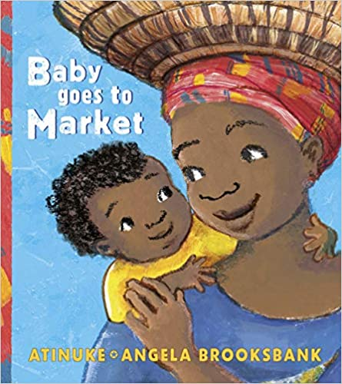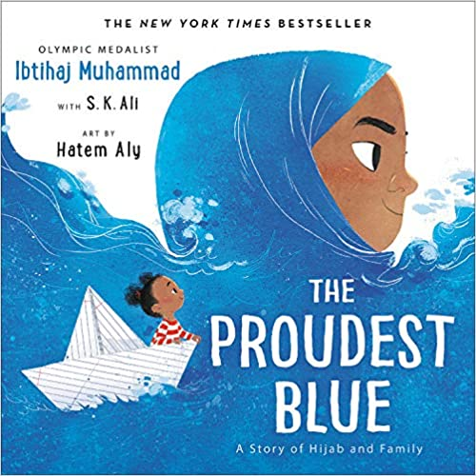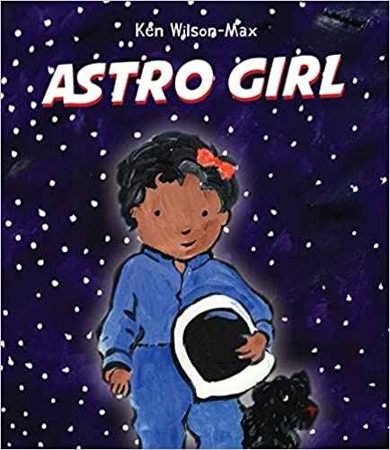
Chitra Soundar, an Indian-born British author and storyteller based in London, writes
‘Young children don’t consciously know they need representation in books. But if every primary school classroom had a bookshelf full of diversity, and every reading list was inclusive, every child in the class would experience the joy of seeing themselves represented in the books they read’.
We have begun a list of picture books for children in Reception and Year 1 with Black, Asian and minority ethnic characters. As teachers, let’s keep adding to it.

- Anna Hibiscus by Atinuke
- Baby Goes to Market by Atinuke
- My Pet Star by Corrinne Averiss
- The Extraordinary Gardener by Sam Boughton
- I Am Enough by Grace Byers
- The New Small Person by Lauren Child
- The Name Jar by Yansook Choi
- So Much! by Trish Cooke
- Ready Steady Mo! by Mo Farah
- Chapatti Moon by Pippa Goodhart
- Amazing Grace by Mary Hoffman
- The Big Bed by Bunmi Laditan
- Julian Is a Mermaid by Jessica Love
- My Friend Earth by Patricia MacLachlan
- Lubna and Pebble by Wendy Meddour
- The Proudest Blue: A Story of Hijab and Family by Ibtihaj Muhammad
- The Garden of Hope by Isabel Otter
- Number 7 Evergreen Street by Julia Patton
- All Are Welcome by Alexandra Penfold
- Ruby’s Worry by Tom Percival
- I Love My Hair! by Natasha Anastasia Tarpley
- Astro Girl by Ken Wilson-Max

