PICTURE BOOKS FOR RECEPTION AND YEAR 1
June 2020

Stories that explore worry and fear
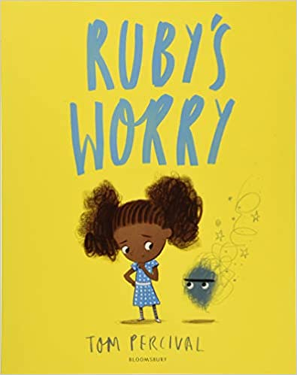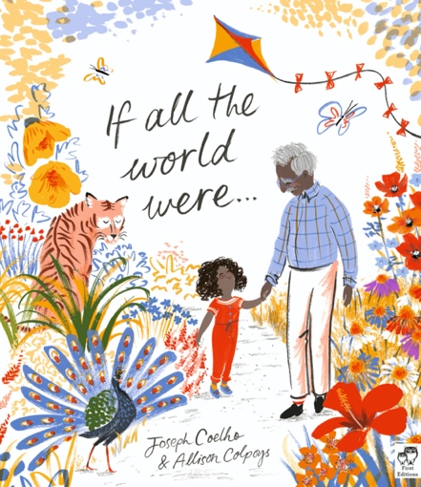

Children may be experiencing worries and anxieties during the return to school phase. We have started a list of picture books to read to children in Reception and Year 1 that introduce these themes. They are wonderful books for any time of the year.

- The Koala Who Could by Rachel Bright
- The Lion Inside by Rachel Bright
- The Worrysaurus by Rachel Bright
- Silly Billy by Anthony Browne
- If All the World Were by Joseph Coelho
- There's a Bear on My Chair by Ross Collins
- Loved to Bits by Teresa Heapy
- Grumpy Monkey by Suzanne Lang
- The Colour Monster by Anna Llenas
- Tough Guys Have Feelings Too by Keith Negley
- Perfectly Norman by Tom Percival
- Ravis’ Roar by Tom Percival
- Ruby’s Worry by Tom Percival
- How Big Are Your Worries Little Bear? By Jayneen Sanders
This book helps talk about germs and hygiene:
- Germs are Not for Sharing by Elizabeth Verdick

